Lecture 4
Internet Applications
Database management
For Chapter 9

Some of the materials in this lecture is not from your book. In the book there are programs in language C in chapter 9. Let us stay with Java in the first half of the semester and devote the second half of the semester to C.

In this chapter, we look at of internet examples. We learn how to read the content of a remote file, how dynamically a server makes a page (an html document) to be displayed on the client browser. We first need the Apache HTTP Server which is the world's most used web server software. Since we are going to use servlets we also need: Apache Tomcat. Finally to be able to use a database manager we select: MySQL. All of these three software are collected in a server named: XAMPP. We also need a dialect of eclipse for Java EE developers that can handle Apache and Tomcat.

1. Installing eclipse for Java EE and XAMPP

To be able to turn your PC to a server and run the related program from eclipse we need a specific version of eclipse. Download this version from: http://www.eclipse.org/downloads/



When you click on the download you are downloading the eclipse installer: 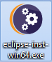
When you click on the installer the following page shows up:

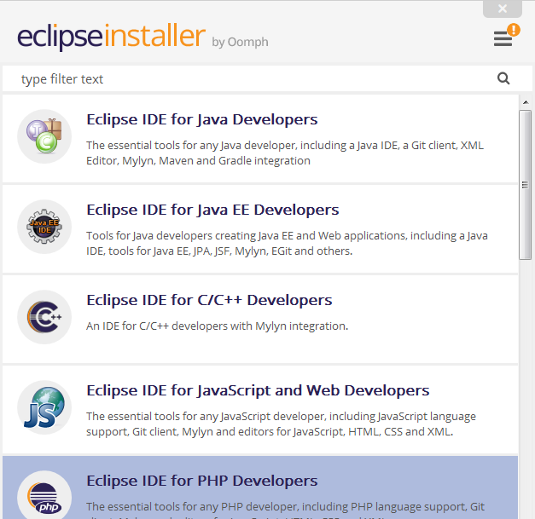

You need to install: Eclipse IDE for Java EE Developers.

You can remove other version(s) of eclipse from your computer.

Downloading and Installing XAMPP

1. Uninstall Apache if you have on your computer.
2. Uninstall MySQL if you have on your computer.
3. Go to the folder: Program Files and delete the folder Apache and MySQL
4. Reboot your computer.
5. Download the installer: xampp-win32-5.6.24-1-VC11-installer.exe from the following website to install: Apache, MySQL, Tomcat etc:
https://www.apachefriends.org/index.html
Note that this installer works for both 32-bits and 64-bits computer. If you have Mac download the version for mac.
Once you run the installer, you'll have c:\xampplite with a folder named: htdocs inside. Note that you can only have one copy of Apache and mySQL running at a time, so if you've installed them before, you'll need to at least stop them first.
After the installer is finished load XAMPP and start Tomcat:

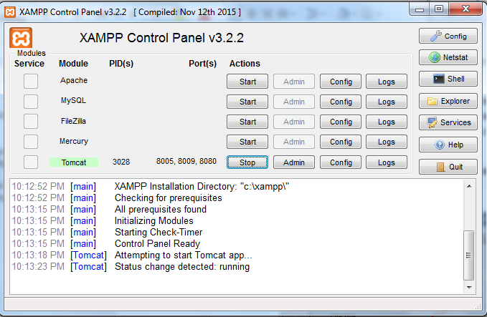
2. Testing

In this section we test the Tomcat, and

Example 1: To test Tomcat enter the following address tab of your browser:

http://localhost:8080/

You should see the following page:
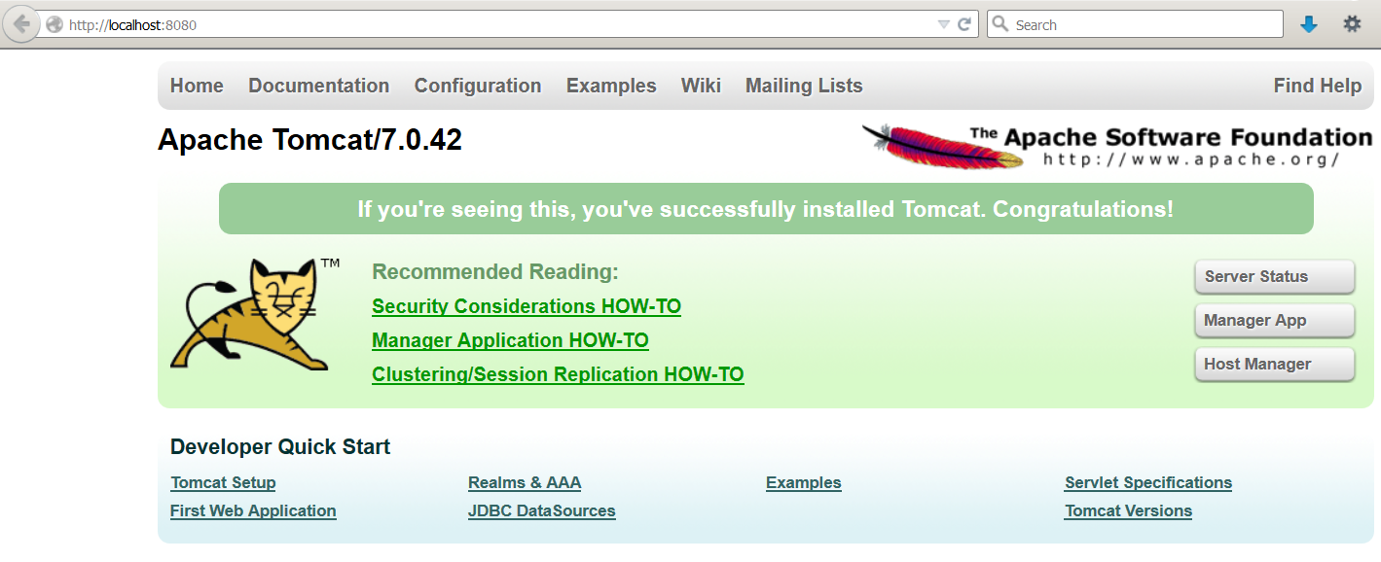

Stop Tomcat.

2. Uniform Resource Locator (URL) review

A URL determines where a resource is in a computer on the network. Its syntax loosely is:

Protocol://IP:port_number/path?query_string

Protocol: A procedure for communication between two computers on the internet. The Hypertext Transfer Protocol (HTTP) is an example of a protocol.

IP: Address of a computer on the internet.

Port-number: This is a number associated with IP. The default port number is: -1. One of the port number we concentrate on in this lecture is: 8080. This port is used by http for web services.

Path: Path is used to specify where the resource is in a computer.

Query-string: The query string contains data to be passed to the server (we will see later in this lecture).

Example 2: The following program checks the syntax (format) of a URL:

import java.net.*;
import java.util.*;

public class Main {
public static void main(String[] args) {
Scanner keyboard = new Scanner(System.in);
System.out.print("Enter a URL: ");
try {
String name = keyboard.nextLine();
URL u = new URL(name);
System.out.println("The protocol is " + u.getProtocol());
System.out.println("The host is " + u.getHost());
System.out.println("The port is " + u.getPort());
System.out.println("The file is " + u.getFile());
} catch (MalformedURLException e) {
System.out.println("Error: " + e);
}
}
}

Output 1:
Enter a URL: http://pace.edu:500/Main
The protocol is http
The host is pace.edu
The port is 500
The file is /Main

Output 2:
Enter a URL: http://pace.edu/Main
The protocol is http
The host is pace.edu
The port is -1
The file is /Main

Output 3:
Enter a URL: http://pace.edu
The protocol is http
The host is pace.edu
The port is -1
The file is

Output 4:
Enter a URL: xyz://pace.edu
Error: java.net.MalformedURLException: unknown protocol: xyz

Output 5:
Enter a URL: http://localhost:8080/test.txt
The protocol is http
The host is localhost
The port is 8080
The file is /test.txt

Description:

The program does not check whether the URL is real or not. It only checks its syntax.
URL u = new URL(name): This instruction uses the java class: URL. It creates an object and lets the variable: u refers to it.
u.getProtocol(): Returns the protocol of the URL.
u.getHost(): Returns the IP (in non-numeric) of the computer.
u.getPort(): Returns the port number.
u.getFile(): Returns the name of the resource(file) the URL is referring to.

Output 1 http://pace.edu:500/Main. We have a complete URL.
Output 2: http://pace.edu/Main. We do not have the port number. The program displays its default which is: -1.
Output 3: http://pace.edu. We do not have the file: Main.
Output 4: xyz://pace.edu. The program jumps to the catch block and displays: Error: java.net.MalformedURLException: unknown protocol: xyz.

3. Reading data from a remote file

In this section we look at two programs for reading a remote text file. The first one reads the files through a URL and the second uses sockets. First we need to open an input stream to read the data from a file. An input stream is an object that inputs data. Next we need to define a buffer to read the data from the file into this buffer and read from the buffer.

Example 3: The following program reads the lines of a file named: test.txt located on a URL and displays them. The content of the file: test.txt is:

This is the first line
This is the second line

Note: The program reads the file from the school server. To read the file from your computer:

1. Load on XAMPP.
2. Start Apache (and not Tomcat). For the school server you do not need this step.
3. To have a separate folder make a folder named: MyWork in: C:\xampp\htdocs.
4. Store test.txt in this folder.
5. In the following program change: "http://vulcan.seidenberg.pace.edu/mb~adii/test.txt" to: "http://localhost/MyWork/test.txt".

In the school server this file is in the folder: public_html in my account.
You can change: ~mbadii to your user name and copy this file in the folder: public_html of your account.

import java.net.*;
import java.io.*;

import java.net.*;
import java.io.*;

public class Main {
public static void main(String[] args) {
try {
//URL u = new URL("http://localhost/MyWork/test.txt");
URL u = new URL("http://vulcan.seidenberg.pace.edu/~mbadii/test.txt");
BufferedReader input=new BufferedReader(new
InputStreamReader(u.openStream()));
String s = input.readLine();
while (s != null){
System.out.println(s);
s = input.readLine();
}
} catch (MalformedURLException e) {
System.out.println(e);
} catch (IOException e) {
System.out.println(e);
}
}
}

Output:
This is the first line
This is the second line

Description:

This program is not using socket to connect to the server:

URL u = new URL("http://vulcan.seidenberg.pace.edu/~mbadii/test.txt"): See example 2.

BufferedReader input=new BufferedReader(new InputStreamReader(u.openStream())):
Creates an input buffer. The system does not read directly from the input stream. The system transfers data to the input buffer in blocks of fixed size (for example 512 characters).

String s = input.readLine(): Reads the first line of the file.

while (s != null){System.out.println(s); s = input.readLine();}: Reads the rest of the file.

Example 4: The following program is using sockets to display detailed information of the remote server and reads the content of a file named: test.txt from the server. This file must be stored in the folder: public_html in your school account.

Note: The program reads the file from the school server. To read the file from your computer:

1. Load on XAMPP.
2. In the window of XAMPP click on start of Apache.
3. To have a separate folder make a folder named: MyWork in: C:\xampp\htdocs.
4. Store test.txt in this folder.
5. In the following program change: "vulcan.seidenberg.pace.edu" to:

String host = "localhost".

6. In the following program change: "GET /~mbadii/test.txt HTTP/1.0\r\n" to:

"GET /MyWork/test.txt HTTP/1.0\r\n"

import java.net.*;
import java.io.*;

public class Main {
public static void main(String[] args) {
try {
int port = 80;
String host = "vulcan.seidenberg.pace.edu";
//String host = "localhost";
Socket clientSocket = new Socket(host, port);
PrintWriter out = new PrintWriter(clientSocket.getOutputStream(), true);
String request = "GET /~mbadii/test.txt HTTP/1.0\r\n";
//String request = "GET /MyWork/test.txt HTTP/1.0\r\n";
out.println(request);
BufferedReader in = new BufferedReader(new InputStreamReader(clientSocket.getInputStream()));
String response = in.readLine();
while (response != null) {
System.out.println(response);
response = in.readLine();
}
clientSocket.close();
}catch (Exception ex) {
System.out.println("ERROR : " + ex) ;
ex.printStackTrace(System.out);
}
}
}

Sample dialog

HTTP/1.1 200 OK
Date: Fri, 13 Oct 2017 16:33:18 GMT
Server: Apache/2.4.23 (Win32) OpenSSL/1.0.2h PHP/5.6.24
Last-Modified: Fri, 07 Oct 2016 02:39:48 GMT
ETag: "31-53e3d52e4ff3a"
Accept-Ranges: bytes
Content-Length: 49
Connection: close
Content-Type: text/plain

This is the first line.
This is the second line.

Description of the output:

The program reads from a file named: test.txt and displays its content on the console. The file has only the following two lines:

This is the first line.
This is the second line.

The previous lines of output show information about the server. These are:

HTTP/1.1 200 OK:
- HTTP/1.1: This protocol is the foundation for data transfer between a client and a server on the: World Wide Web (WWW).
- 200: The state code. This code means everything is: OK and there is no error. If we change the name of the file to a file name that does not exist (like: test2.txt) we get: HTTP/1.1 404 Not Found. In this case the state code is 404 to show there is an error and the error is file: Not Found.

To learn about status code such as 200, or 404 refer to:

http://www.w3.org/Protocols/rfc2616/rfc2616-sec10.html

Date: Fri, 13 Oct 2017 16:33:18 GMT: Date of the execution of this program.

Server: Apache/2.4.23: The name of the server program is: Apache and the operating system on the server computer is: Debian which is a dialect of LINUX.

Last-Modified: Fri, 07 Oct 2016 02:39:48 GMT: The last time the file modified.

ETag: "31-53e3d52e4ff3a": Called: Entry tag to validate web cash (read page 246 for web cash).

Accept-Ranges: bytes: Servers informs the client that accepts requests in bytes.

Content-Length: 49: The file contains 49 characters including the carriage return, end-of-file, and space characters.

Connection: close: After the execution of the client program is finished the connection is closed.

Content-Type: text/plain: The content of the file is plain text (e.g. has no picture)

Description of the program

The idea in this program is to learn how the client requests from a server and how the server responds.

int port = 80: This port is for HTTP.
Socket clientSocket = new Socket(host, port): Creates socket object and connects to the: host at specified: port.
PrintWriter out = new PrintWriter(clientSocket.getOutputStream(), true):
Creates a PrintWriter object to be able to send (write) request (a string) to the server.

String request = "GET /~mbadii/test.txt HTTP/1.0\n\n": To request the content of the file: test.txt using the protocol: HTTP/1.0.

Note: To run the program on your school server account change: mbadii to your user name.

There are two HTTP methods to accomplish this request:
- GET: To retrieve (get) the contents of the web documents.
- POST: To send data to the server.

For more detail on GET and POST refer to: http://www.w3schools.com/TAGS/ref_httpmethods.asp

Both GET and POST brings the same data from the server to the client. The difference between GET and POST is clearer when we send an html document to the server. An html document contains command buttons, text boxes, and radio buttons, etc. objects. Each object has a name and a value (content). A browser send the sequence of these (name, value)’s to the server. When GET method is use these pairs are visible in the location bar of the browser. But with the POST method they are not visible.
out.println(request): Sends (write) the request: "GET /~badii/test.txt" to the server.

String response = in.readLine(): The server responds. The program one line from the file: test.txt which is on the server.

while (response != null){System.out.println(response);response = in.readLine();}: Keeps displaying and reading all the lines of the file: test.txt.

The program gets even easier if we are not interest in the detail of the server and we only like to see the content of the file. In this case we use the class URL in place of socket.

Example 5: The following program reads the content of a file named: test.txt from a server, but does not display the information about the server. Note that this program is not using a socket to communicate with the server. Therefore using a socket in a request-respond procedure is not necessary.

import java.net.*;
import java.io.*;

public class Main {

public static void main(String[] args) {
try {
URL theURL = new URL("http", "vulcan.seidenberg.pace.edu", 80, "/~mbadii/test.txt");
BufferedReader in = new BufferedReader(new InputStreamReader(theURL.openStream()));
String response = in.readLine();
while (response != null) {
System.out.println(response);
response = in.readLine();
}
}catch (Exception ex) {
System.out.println("ERROR : " + ex) ;
ex.printStackTrace(System.out);
}
}
}

Sample dialog

This is the first line.
This is the second line.

Description

Only the following instruction is new. The rest are in the program of example 4.

URL theURL = new URL("http", "vulcan.seidenberg.pace.edu", 80, "/~mbadii/test.txt"): This creates an object of the type class: URL with one of its constructors. The first argument specifies the protocol. The second one is the host address, the third one is the port number in the server, and the last one is the file name and the user name.

With HTTP1.0, a connection to a server is automatically closed as soon as the server returns a response. Thus exactly one round of exchange is allowed between a client and a web server; if a client needs to contact the same server in another session, it must reconnect to the server to reissue another request. The scheme is adequate for the original intent of HTTP for retrieving simple network documents. It is inefficient for documents such as those that contain a large number of links to image objects to be fetched by the server, since fetching each of these links require a reestablishment of a connection.

With the following concepts we can send and receive data more elegantly.

4. Dynamically Generated Web Content using Common Gateway Interface

Eclipse is one of the most convenient IDE to handle servlets. Data moves between a client program to a server program using sockets, URLs, and servlets, JSP (Java Server Page), etc. A Java servlet is a Java Objects that extends the capabilities of a server. This object can receive a request and generates a response based on that request.
Since we like to include html code in a java program, we need an IDE to be able to run and debug our program. Eclipse is the vehicle for our work.
Note: If you are using any other IDE you need to either switch to eclipse or learn how to use your IDE for the following material and through the end of the course.

In the rest of this section we will cover:

1. Creating an Apache Tomcat server.
2. Creating a dynamic Web project
3. Creating an HTML document.
5. Creating a Servlet.

4.1. Creating an Apache Tomcat server

When we create server, a dynamic web project, an html and/or a servlet via eclipse we must stop every module and quit XAMPP:

1. Create an empty folder and load eclipse for this folder. Do not make a java project.
On the menu bar click: New → Other → Server → Server to see:

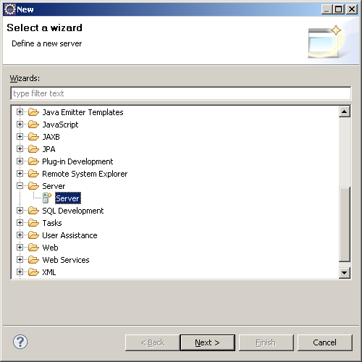

Click: Next.

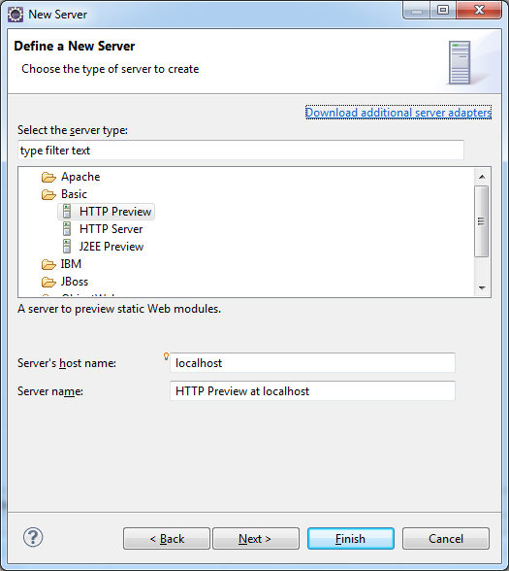

Expand the icon Apache and select Tomcat v7.0 Server to see:

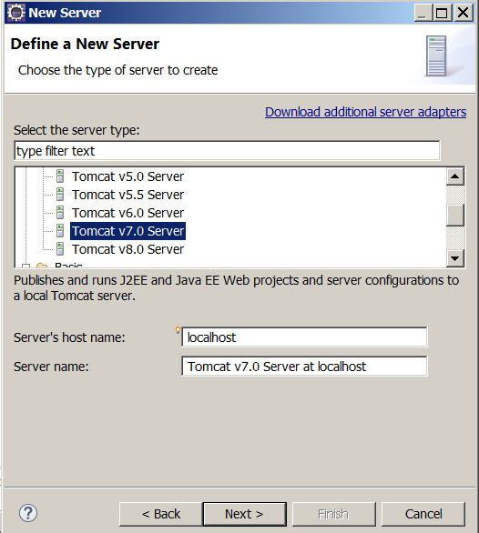

2. Click Next:

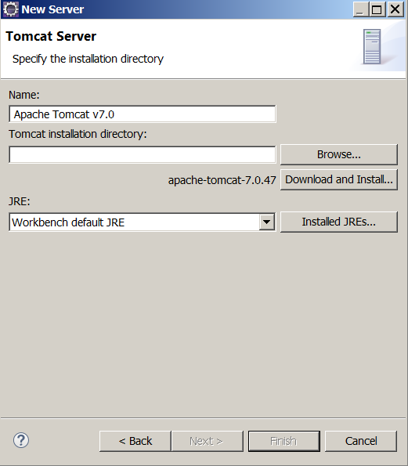

3. Browse, find and insert the path of Tomcat 7.0 to see:

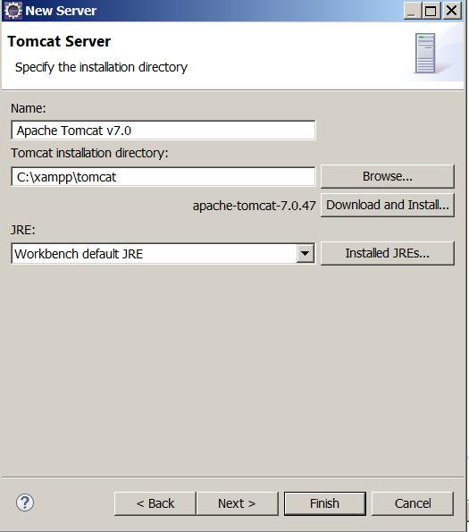

4. Click Finish. The Project Explorer should be:

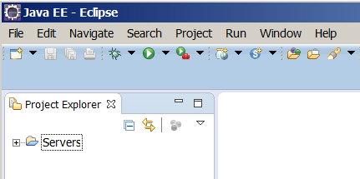

4.2. Creating a dynamic Web project

1. Click File → New → Other → Web → Dynamic Web project:

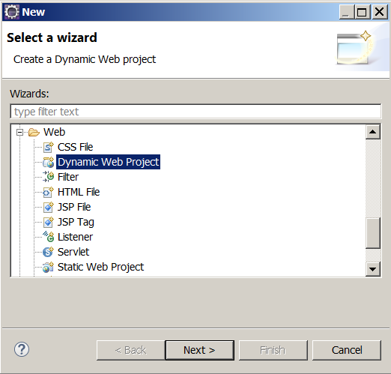

2. Click: Next and name this project. I named it: Project
Note: The name of the dynamic project should be one word.
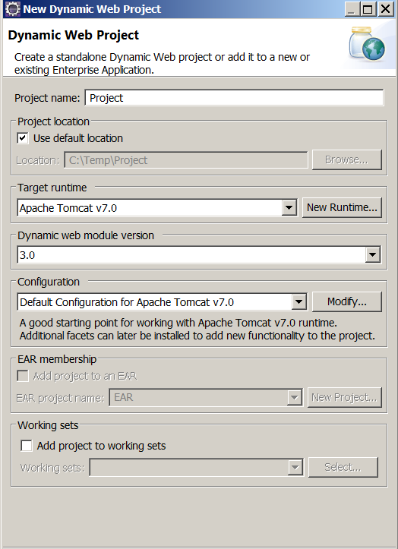

3. Click: Finish. The eclipse editor should be:

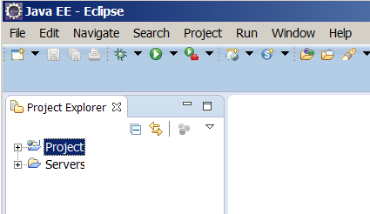

Note: Creating a server and a dynamic project is a must be for HTMLs, and Servlets.

4.3. Creating an HTML document

In this section we create a simple html document in eclipse.

Example 6: The following steps create an html document that displays the message: Hello there.

1. In the Project Explorer, expand your project to see:

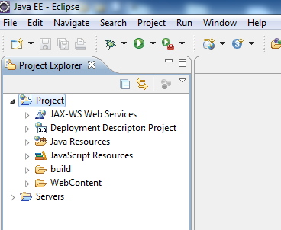

2. Right click on the folder: WebContent and click on: New to see:

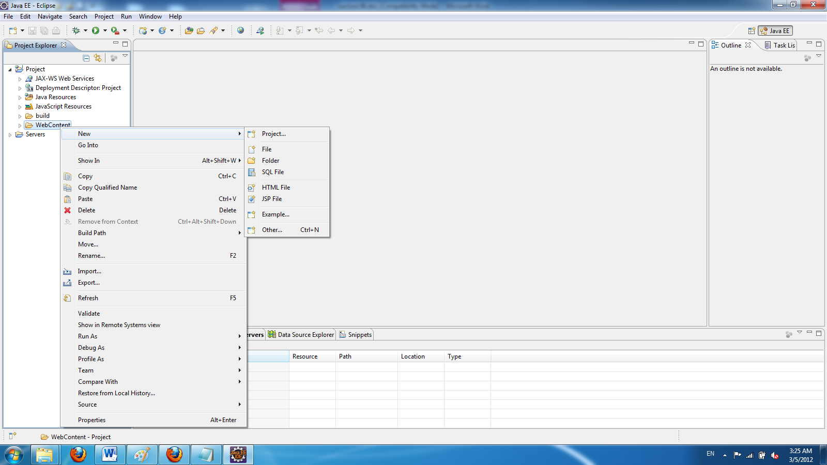

3. Click on HTML File page to see:

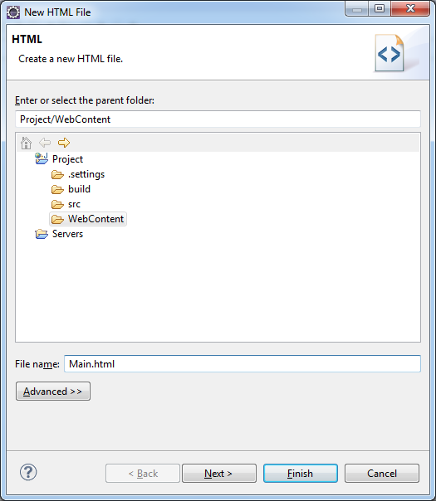

4. Enter a file name (I named it Main.html) and click Finish. The content of the editor is:

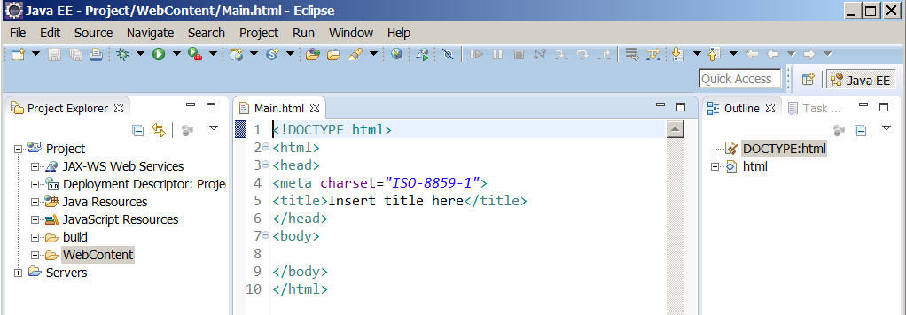

5. Replace the content of the editor by:

<html>
<head>
<meta http-equiv="Content-Type" content="text/html; charset=ISO-8859-1">
<title>Hello</title>
</head>
<body>
<h1>Hello there ! </h1>
</body>
</html>

5. Click on run icon to see:

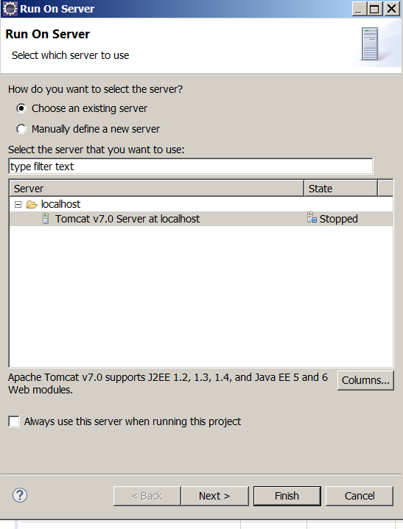

6. Select Tomcat v7.0 server and click on: Finish to see:

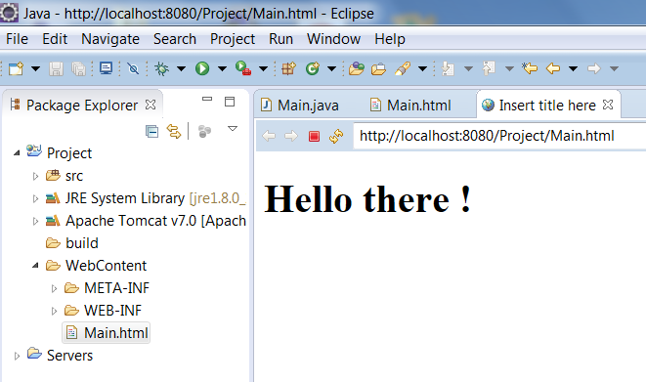

7. Stop the tomcat server by clicking on the small red rectangle on the lower window (from: console window). Close the html page.
Note: Click on: to refresh the page if the you had a different html and copy/paste the new html document over the old one.

4.4. Creating a Servlet

In this section we create a servlet for the server side.

Example 7: We like to make a servlet to send an html document to the client side. This document is made dynamically. The html document displays: Hello there.

1. In the Project Explorer, expand your project and right click on WebContent → New → Others to see:
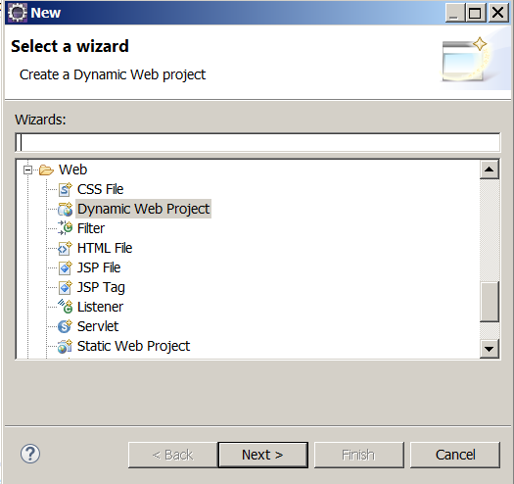

2. Select Servlet and click Next:

3. Enter a class name (I entered Main):

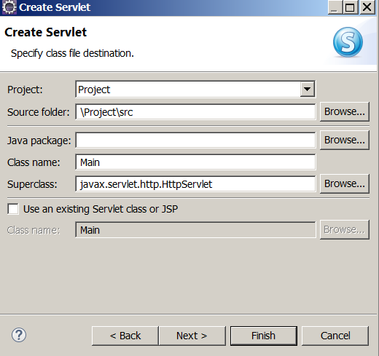

Note: Since you have only one class there is no need to have a package. Therefore leave the package window blank.

4. Click Finish. The content of the editor should be:

import java.io.IOException;
import javax.servlet.ServletException;
import javax.servlet.annotation.WebServlet;
import javax.servlet.http.HttpServlet;
import javax.servlet.http.HttpServletRequest;
import javax.servlet.http.HttpServletResponse;

/**
* Servlet implementation class Main
*/
@WebServlet("/Main")
public class Main extends HttpServlet {
private static final long serialVersionUID = 1L;

/**
* @see HttpServlet#HttpServlet()
*/
public Main() {
super();
// TODO Auto-generated constructor stub
}

/**
* @see HttpServlet#doGet(HttpServletRequest request, HttpServletResponse response)
*/
protected void doGet(HttpServletRequest request, HttpServletResponse response) throws ServletException, IOException {
// TODO Auto-generated method stub
}

/**
* @see HttpServlet#doPost(HttpServletRequest request, HttpServletResponse response)
*/
protected void doPost(HttpServletRequest request, HttpServletResponse response) throws ServletException, IOException {
// TODO Auto-generated method stub
}

}

5. Replace this program with the following and run it:

import java.io.IOException;
import java.io.PrintWriter;
import javax.servlet.ServletException;
import javax.servlet.annotation.WebServlet;
import javax.servlet.http.HttpServlet;
import javax.servlet.http.HttpServletRequest;
import javax.servlet.http.HttpServletResponse;

@WebServlet("/Main")
public class Main extends HttpServlet {
private static final long serialVersionUID = 1L;

public Main() {
super();
}

protected void doGet(HttpServletRequest request, HttpServletResponse
response) throws ServletException, IOException {
PrintWriter out = response.getWriter();
out.println("<html><title>Hello</title><body>\n");
out.println("<font color = blue>");
out.println("<h1>Hello there!</h1>\n");
out.println("</font>");
out.println("</body></html>");
out.close();
}
}

You should see:

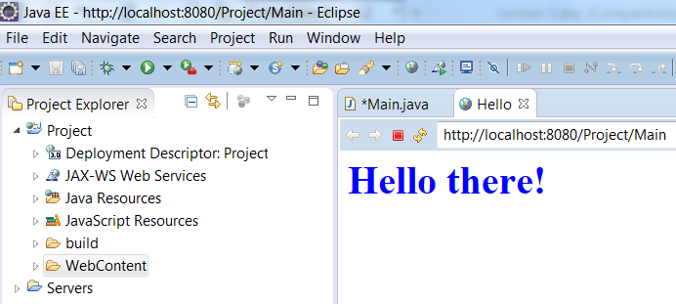

Note: This is a java class. You should not get any error.

Note: Always click on the tab: Console to make sure no other program is running. If you have a situation like the following screen shot click on the small red button to stop a program:

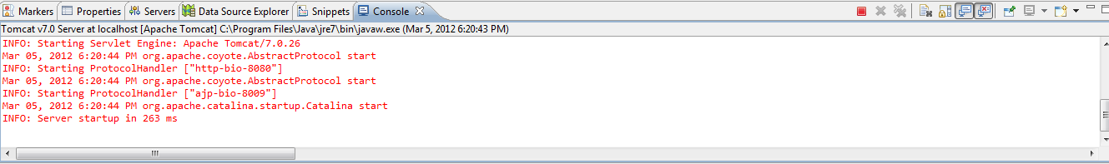

As we notice from the previous example HTTP can transfer static contents like the content of a text file or an image. We also can allow a browser to retrieve information in a database on the server side. For example when a user enters a credit card number and submits to the server we can have a program that checks in a database to find out whether or not the number is in the list of credit card numbers. The server can dynamically make an html document and display the client browser to inform the credit card is valid or invalid.

Exercise 1: Write a servlet displays: Hello there! or displays: Have a good night on a web page. The program should prompt the user: Enter: yes to display: Hello there or enter no to display: Have a good night.

Exercise 2: Write a servlet that counts how many times the program is executed provided not to stop the server.

A Web Form

The examples in the book are in C. I rather prefer Java at this stage. I am assuming you have installed and tested the Apache. For the client side we design an html document that contains the html tag: form to be able to submit the page to the server program.

Example 8: The following is a simple html document with a tag form:

<html>
<head>
<meta http-equiv="Content-Type" content="text/html; charset=ISO-8859-1">
<title>A simple example</title>
</head>
<body>
<form action="http://localhost:8080/Project/Main" method = "get">
Enter Your Name: <input type="text" name="yourName"><br>
Enter Your Age&nbsp;&nbsp;&nbsp;&nbsp;:<input type="text" name="yourAge"><br>
<input type="submit" value="Click to submit">
</form>
</body>
</html>

Note: The name: Project should exactly be the same as the name of the eclipse dynamic project.
When we make an html document in eclipse (similar the way I explained for installing a servlet class) this page displays:

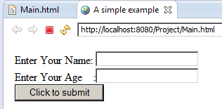

This html document has three objects: Two text boxes and a command button. Each object has a name and value. When we click on the submit button a sequence of these pairs (name, value) are sent to the server program. The line:

<form action="http://localhost:8080/Project/Main" method = "get">

Specifies that the file: Main.class in the folder: Project\build\classes. I named the eclipse project: Project. The segment: method = "get" instructs the server to executed the method: doGet. Let us define this method in the servlet class Main:

Solution 1: If our html document has a few objects (text fields, buttons, labels) we can use the following Servlet:

import javax.servlet.ServletException;
import javax.servlet.annotation.WebServlet;
import javax.servlet.http.HttpServlet;
import javax.servlet.http.HttpServletRequest;
import javax.servlet.http.HttpServletResponse;
import java.io.*;

@WebServlet("/Main")
public class Main extends HttpServlet {
private static final long serialVersionUID = 1L;
public Main() {
super();
}

protected void doGet(HttpServletRequest request, HttpServletResponse
response) throws ServletException, IOException {
String value = request.getParameter("yourName");
System.out.println("(yourName, " + value + ")");
value = request.getParameter("yourAge");
System.out.println("(yourAge, " + value + ")");
}
}

Solution 2: When the html document has a number of objects (more than 3, or 4) the following solution is better:

import javax.servlet.ServletException;
import javax.servlet.annotation.WebServlet;
import javax.servlet.http.HttpServlet;
import javax.servlet.http.HttpServletRequest;
import javax.servlet.http.HttpServletResponse;
import java.io.*;
import java.util.Enumeration;
@WebServlet("/Main")
public class Main extends HttpServlet {
private static final long serialVersionUID = 1L;
public Main() {
super();
}

protected void doGet(HttpServletRequest request, HttpServletResponse
response) throws ServletException, IOException {
Enumeration<String> names = request.getParameterNames();
while (names.hasMoreElements() ){
String name = (String)names.nextElement();
String value = request.getParameter(name);
System.out.println("(" + name + ", " + value + ")");
}
}
}

Display output:

We run the html document and enter: Jon Doe and 45 for the name and age:

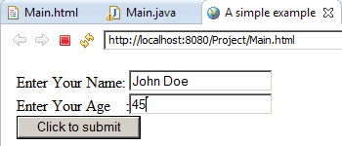

Now we click on the submit button the following page shows up:

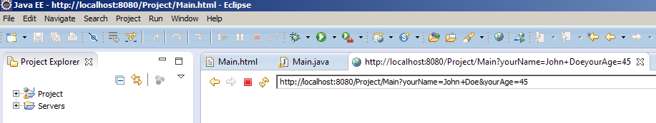

Then the method: doGet of Main.java gets executed and displays the following pairs on the console:

(yourName, John Doe)
(yourAge, 45)

5. Creating and using cookies

Cookies are used to store a small amount (4K) of information on the client’s computer. The server can track a client’s computer to find out whether or not the client has been contacting before. The javax.servlet.http contains a Cookie class that allows you to quickly set up and process HTTP cookies. In other words the server sends a cookie to a browser to be stored in the client computer with some attributes such as a comments, path, a maximum age, and a version number. If the client next time makes a new connection and makes request the server can access the cookie (which is stored in the client’s computer) to find the information that has been stored previously. Cookies can be made to save the user names and passwords. In this case the user does not have to enter username/password when she/he wants to request from the same server.

A servlet program can create a cookie object by: new Cookie(name, value) and adds the cookie by calling: addCookie(cookie) to the browser’s space on the client’s computer. If the client requests from the same server the server reads the client’s cookies by calling: getCookies(). Some methods that are useful in processing cookies are: getCookies(), getName(), getValue(), setValue(aString), setMaxAgeint (anInteger), setPath(URI), getPath(),getDomain( ), and setDomain(aDomain) to retrieve, get the name, get the value, set the value, set the maximum age in seconds, specify path, get the path, get the domain, and to set the domain of a cookie respectively.

You can delete one or all the cookies from your window. For example in the IE or Firefox browser we hit Ctrl-Shift-Delete to delete cookies.

Example 9: The following program sends a cookie to a client.

A: The html document:

<!-- Main.html -->
<!DOCTYPE html PUBLIC "-//W3C//DTD HTML 4.01 Transitional//EN" "http://www.w3.org/TR/html4/loose.dtd">
<html>
<head>
<meta http-equiv="Content-Type" content="text/html; charset=ISO-8859-1">
<title>Servlet Example</title>
</head>
<body>
<form action="http://localhost:8080/Project/Main">
<center>
<br><br>
<input type="submit">
</center>
</form>
</body>
</html>

B: The servlet:

import java.io.*;
import javax.servlet.ServletException;
import javax.servlet.annotation.WebServlet;
import javax.servlet.http.HttpServletRequest;
import javax.servlet.http.HttpServletResponse;
import javax.servlet.http.Cookie;

@WebServlet("/Main")
public class Main extends javax.servlet.http.HttpServlet implements javax.servlet.Servlet {

public Main() {
super();
}

protected void doGet(HttpServletRequest request,
HttpServletResponse response)throws ServletException, IOException {
Cookie aCookie = new Cookie("myName", "myValue");
aCookie.setMaxAge(60*60*24*365); // 1 year
response.addCookie(aCookie);
response.setContentType("text/html");
PrintWriter out = response.getWriter();
out.println("<html>\n" +
"<head><title>Processing Cookies</title></head>\n" +
"<body bgcolor=\"#fdf5e6\">\n" +
"<h1 align=\"center\"> Thanks I will remember you</h1>\n" +
"</body></html>");
}
}

When you click on the submit button:

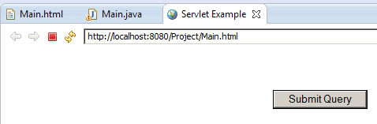

You get the following page.

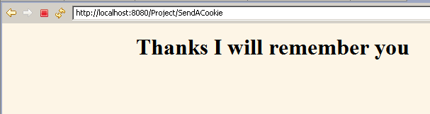

Description:

The instruction:

Cookie aCookie = new Cookie("myName", "myValue");

Creates a Cookie object and passes the name myName and the value myValue to the object through the constructor. Note that the value also is a string.
Note: In your project/exam you will have different strings for name and value. You cannot choose myName for name and myValue for value. These strings comes from textboxes of an html document. Therefore you must not have quotations (i.e. ") when creating a new cookie.

The instruction:

aCookie.setMaxAge(60*60*24*365);

Means the cookie in the client computer is stored for a year by the next instruction (provided the user do not delete it !).
Note: To remove a cookie via your java program write:

aCookie.setMaxAge(0);

Finally the instruction:

response.addCookie(aCookie);

Adds the cookie to the client computer.

We can track a client by a cookie that has been stored to his/her computer before.

Example 10: The following servlet checks if a client has been visited the server.

Note: We use the html document of the previous example.

B: The servlet:

import java.io.IOException;
import java.io.PrintWriter;
import javax.servlet.ServletException;
import javax.servlet.annotation.WebServlet;
import javax.servlet.http.Cookie;
import javax.servlet.http.HttpServletRequest;
import javax.servlet.http.HttpServletResponse;

@WebServlet("/Main")
public class Main extends javax.servlet.http.HttpServlet implements javax.servlet.Servlet {

public Main() {
super();
}

protected void doGet(HttpServletRequest request, HttpServletResponse response)
throws ServletException, IOException {
boolean found = false;
String message = "Thank you for visiting us again";
Cookie[] cookies = request.getCookies();
if (cookies != null && cookies.length > 0)
for(int i=0; i<cookies.length; i++) {
Cookie c = cookies[i];
if ((c.getName().equals("myName")) && (c.getValue().equals("myValue"))){
found = true;
break;
}
}
if(! found)
message = "I am sorry you have not visited us before.";
response.setContentType("text/html");
PrintWriter out = response.getWriter();
out.println("<html>\n" +
"<head><title>Processing Cookies</title></head>\n" +
"<BODY BGCOLOR=\"#FDF5E6\">\n" +
"<h1 alighn\"center\">" + message + "</h1>\n" +
"</body></html>");
}
}

If you have not deleted the cookies through IE browser and click on the Submit button you get the following page:

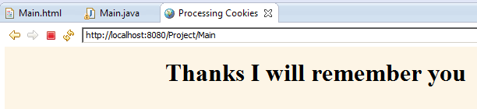

On the other hands if you have deleted cookies (Ctrl-Shift-Delete) you get the following page:

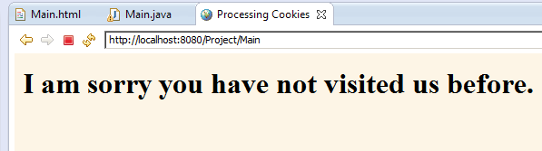

Description: In the server the instruction:

Cookie[] cookies = request.getCookies(): Accesses all the cookies from the client computer.

Provided there are cookies, the for-loop:

for(int i=0; i<cookies.length; i++) {
Cookie c = cookies[i];
if ((c.getName().equals("myName")) && (c.getValue().equals("myValue"))){
found = true;
break;
}
}

The loop looks for a specific cookie by the name "myName" and the value "myValue". If there is such a cookie changes the value of the variable: found to true and the control of execution breaks out of the loop.

Now the following conditional statement is executed:

if(! found)
message = "I am sorry you have not visited us before.";

Since the condition evaluates to: false the content of the variable: message won’t change and the program issues the message: "Thank you for visiting us again".
If the cookie is not available the above for-loop takes all its iterations and the control of execution goes after the loop and execute the above conditional statements. Since the value of the variable: found is false the condition is evaluated to true and the content of variable: message is changed to:

message = "I am sorry you have not visited us before.";

The control of execution then makes a dynamic html document and writes (out.println…) to display appropriate page on the client’s browser.

6. Database management

To be able to store data and retrieve them efficiently we use a database manager. Let us first get familiar with a database and then we bring it to the servlet.

6.1 Creating a database through DOS window
There are two ways to create databases:
By clicking on the Amin button in the XAMMP control panel. This loads an html document and we use it to create a database. This approach is nice but does not serve our goal for using MySQL instructions in a java program. To use these instructions in a programt we need to learn the syntax of the database manager language. This approach does not show the syntax of the instructions.
a) Load XAMPP and click on the start button of MySQL.
b) By loading the DOS window and activating the database manager. With this is approach we learn the syntax of the database manager.
Example 11: In this example we create a database named: mydatabase and a table named: myTable using the DOS window. Each row is a record of a person. The information for a person is:
First Name
Last Name
Birth date
Dependents
SS#
All the following instructions are done in DOS window.
1. Enter:
C:\xampp\mysql\bin\mysql.exe --local-infile --user=root --password=
The option: local-infile enables a database to load a table from a local input file.
Note: Once again: Do not enter a password. Make sure there is no space or tab after the symbol: = to see:
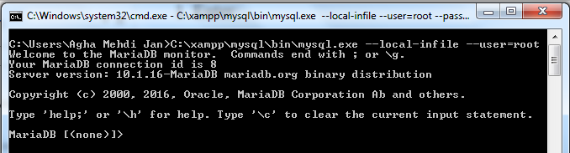
2. First we want to be sure there is no database named: mydatabase in my system. To do this we enter:
SHOW databases;
You should get:
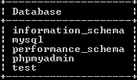
Note: You may get a slightly different pictures.
Note that MySQL is not case sensitive. There is no difference between upper and lower case letters. But we enter the instructions in upper case and our names in lower case letters. Therefore in “DROP DATABASE mydatabase;” The part “DROP DATABASE” is a MySQL instruction and “mydatabase” is our name for the database.
3. Although we can use the database named test but we prefer to create our own. Enter:
CREATE DATABASE mydatabase;
To see:
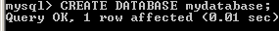
4. Now enter the following instruction to use this database:
USE mydatabase;
To see:
5. Let us create a table with the following fields:
Field’s name | Type
Firstname | VARCHAR(20)
Lastname | VARCHAR(20)
Birthdate | DATE
Dependents | INT
ss | VARCHAR(11)

There are many types in MySQL. The above one are a few of them:
VARCHAR(20) means the name is a variable of type on an array of 20 character .
DATE means the name is of type date. Therefore DATE is a type. The type DATE is in the format of YYYY-MM-DD.
INT means the name is of type integer.
CREATE TABLE mytable (firstname VARCHAR(20), lastname VARCHAR(20), birthdate DATE, dependents INT, ss VARCHAR(11));
You should see:
Note that the instruction is all in one line.
6. To make sure we have the right layout for our table, enter:
DESCRIBE mytable;
To see:
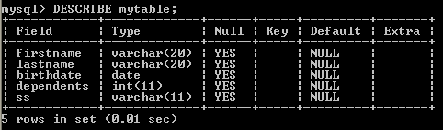
7. We now enter 20 names in the table. Obviously entering data via keyboard is a little hard and we may mistake. Therefore we enter these names into a text file and load the text file into the table. The other advantage of this is we can use the text file for other tables and can change its content easier.
Item on the same line in the text file should be separated by one tab key. Only ONE TAB.
Jane Doe 1952-09-12 0 123-45-6789
John Doe 1944-08-23 2 213-45-6789
Adam Smith 2004-05-01 0 321-45-6789
Ann Smith 2006-06-02 1 123-54-6789
Joe Bean 1988-11-05 4 123-44-0221
Mike Smith 1999-12-22 0 234-43-1202
Sara Doe 2008-11-16 0 675-54-9845
John Reivik 1999-12-25 1 234-55-1256
Rose Nigel 1977-05-29 5 345-62-5731
William Smith 1987-10-12 0 254-67-9832
Danielle Davis 1944-12-13 6 254-23-6734
David Depaoli 1988-10-15 2 345-78-4321
Thomas Iacovelli 2000-01-01 0 345-83-5674
Dominick Olsen 1942-05-06 5 673-35-0120
John Yolas 1987-12-23 2 370-20-2298
Danielle Williams 2001-10-25 0 402-25-1002
Elaine Ramos 1977-09-08 3 204-56-7821
George Perez 1999-01-03 1 276-45-1856
Elaine Silva 2002-11-25 0 280-23-6002
Angela Dawnell 1988-09-24 1 872-56-0203

8. We save this file with the name names.txt in folder Temp in drive C.
In order to load the table with the content of this file we enter:
LOAD DATA LOCAL INFILE "C:/Temp/names.txt" INTO TABLE mytable;

To see:
Note: Be careful. You should enter the correct path.
9. Let us display the table. To display the table enter:
SELECT * FROM mytable;
We should see:

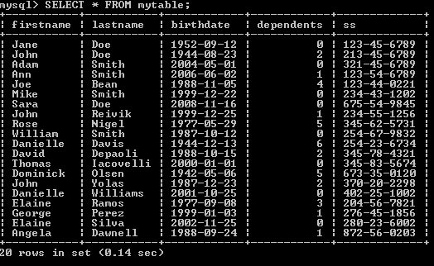
10. It is possible that we make mistake in designing the text file. For example if we pressed the tab key twice after Jane in the text file we get the following:

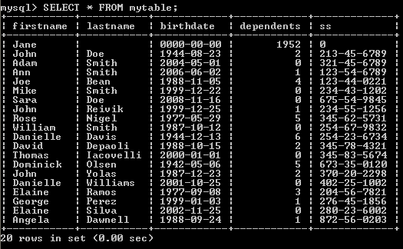
In this case we need to correct the text file, delete the content of the table, and load the text file again.
11. To delete the content of the table enter:
DELETE FROM mytable;
12. We now would like to sort the table by the last name. Enter:
SELECT * FROM mytable ORDER BY lastname;
Now let us look at the content of the table:
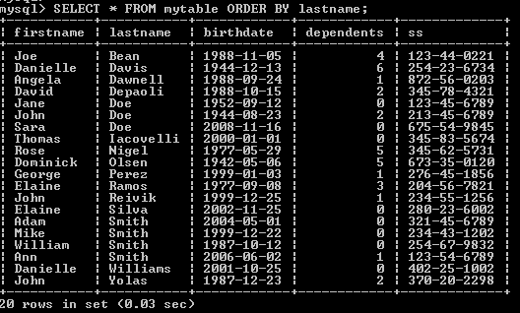
13. We also may need to search the table for a specific person. Enter:
SELECT * FROM mytable WHERE lastname = "Perez";
We see:

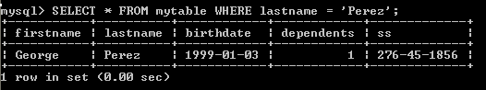

Or for:
SELECT * FROM mytable WHERE lastname = "Doe";
We see:
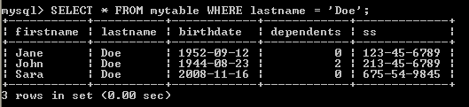

What happens if the last name is not in the table? To see enter:
SELECT * FROM mytable WHERE lastname = "XX";

We see:
The response is Empty set.
14. To select part of the information for a specific person like the first name and the date of birth of a person we write:
SELECT firstname,birthdate FROM myTable WHERE lastname="Doe";
15. To select a row based on two conditions we write:
SELECT firstname,birthdate from mytable where lastname = "Doe" and firstname = "John";

We see:
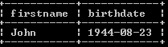
16. To insert in the table we write information for a new person:
INSERT INTO myTable (firstname, lastname, birthdate, dependents, ss) VALUES ("Mehdi", "Badii", "1959-09-12", 3, "123-12-1234");

17) We can update an item of the table:
UPDATE mytable SET lastname = "Doexxx" WHERE lastname = "Doe";
There are many instructions in MySQL. But this course is not about database management. I only want to show you how to use a database management.
18. Since I do not like to have a lot of databases I use the drop-instruction to drop the database made in the provious chapter. Enter the following:
DROP DATABASE mydatabase;
19. Finally to quit from the database manager enter:
quit;
Usefule information:
Find the version of MySQL by:
SELECT version();
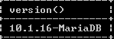
Then go to the following website to access many useful items of this version:
http://dev.mysql.com/doc/refman/5.1/en/
On this website scroll down to read its Table of Contents.

7. Working with database from a Java program:

To work with mysql within java we need to connect Java to mysql via eclipse

7.1 Downloading the MySQL JDBC Driver

JDBC stands for Java Data Base Connectivity.

1. From the blackboard download the file: mysql-connector-java-5.1.12-bin.jar

2. Copy this file into two folders:

C:\Program Files\Java\ jre1.8.0_102 \lib\ext

Note: It is OK if you have a different version of jre.
7.2 Writing a java program in eclipse

In this section we look at four examples. The first two are just Java program and the last two are Java servlets.
Note: To run MySQL from eclipse it should be turned on.

Example 12:

1. Make an empty folder and a java project named Project for eclipse. Make a class called: Main. On the menu bar click on: Project → Properties and click on Java Build Path and select tab: Libraries:

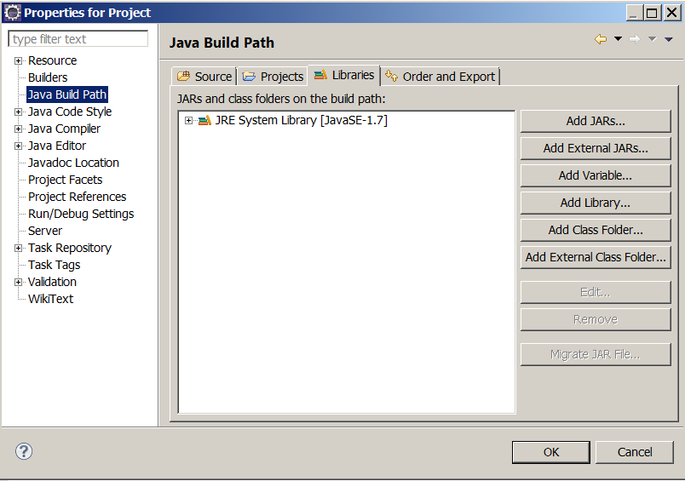

3. Click on: Add External JARs… and find the file mysql-connector-java-5.1.15-bin.jar which is in the folder:

C:\Program Files\Java\jre6\lib\ext

Note: I assume you have already copied (moved) this file to the above folder.
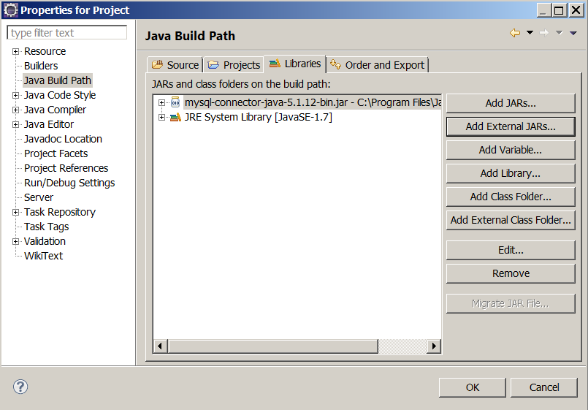

6. Click OK.

7. Copy the following classes in place of your Main class. Load XAMPP and start MySQL.

import java.sql.Connection;
import java.sql.DriverManager;

public class Main {
public static void main(String[] args) {
try {
Class.forName("com.mysql.jdbc.Driver").newInstance();
Connection conn = DriverManager.getConnection(
"jdbc:mysql://localhost/test?user=&password=");
} catch (Exception ex) {
System.out.println("LocalizedMessage: " +
ex.getLocalizedMessage());
System.out.println("Message: " + ex.getMessage());
System.out.println("Cause: " + ex.getCause());
System.out.println("Class: " + ex.getClass());
System.out.println("StackTrace: " + ex.getStackTrace());
System.exit(0);
}
System.out.println("Program terminated with no error.");
}
}

The output should be:

program terminated with no error.

Note: I did not assign any user name and password to MySQL. If you did you need to change:

"jdbc:mysql://localhost/test?user=&password=")

To:

"jdbc:mysql://localhost/test?user=YOUR-USER-NAME&password=YOUR-PASSWORD")

If your user name or password is wrong you get:

LocalizedMessage: Access denied for user ' YOUR-USE-NAME '@'localhost' (using password: YES)
Message: Access denied for user 'YOUR-USE-NAME'@'localhost' (using password: YES)
Cause: null
Class: class java.sql.SQLException
StackTrace: [Ljava.lang.StackTraceElement;@19c26f5

If you give the wrong database name like the following in place of: test

testA

You get:

LocalizedMessage: Unknown database 'testa'
Message: Unknown database 'testa'
Cause: null
Class: class com.mysql.jdbc.exceptions.MySQLSyntaxErrorException
StackTrace: [Ljava.lang.StackTraceElement;@19c26f5

Note: The data base test is already in MySql when you install.

Description

There are two statements new in the program:

Class.forName("com.mysql.jdbc.Driver").newInstance();
Connection conn = DriverManager.getConnection(
"jdbc:mysql://localhost/test?user=&password=");

The first statement loads the JDBC driver. The second instruction establishes a connection to the database named test. Note that the database test is already in mysql and we do not have to make it.

The URL is: jdbc:mysql://localhost/
The name of the database is: test
Note: To learn the syntax (format) of MySQL instructions refer to:

http://dev.mysql.com/doc/refman/5.0/en/drop-table.html

Example 13: Let us make a table with one row:

import java.sql.*;
import java.util.Scanner;
public class Main {
public static void main(String[] args) {
try {
Class.forName("com.mysql.jdbc.Driver").newInstance();
Connection con = DriverManager.getConnection(
"jdbc:mysql://localhost/?user=root&password="); //I
Statement stmt = con.createStatement();
stmt.execute("CREATE DATABASE IF NOT EXISTS mydatabase"); //II
stmt.execute("USE mydatabase");
stmt.execute("DROP TABLE IF EXISTS simple");
stmt.execute("CREATE TABLE IF NOT EXISTS simple( name char(30))");
stmt.execute("INSERT INTO simple VALUES(\"John Doe\")");
stmt.execute("INSERT INTO simple VALUES(\"Jane Doe\")");
ResultSet rs = stmt.executeQuery("SELECT * FROM simple");
while ( rs.next())
System.out.println(rs.getString(1));
} catch (Exception ex) {
System.out.println("Message: " + ex.getMessage());
System.exit(0);
}
System.out.println("Program terminated with no error.");
}
}

The output of this program is:

John Doe
Jane Doe
Program terminated with no error.

Description

The instruction:

Statement stmt = con.createStatement();

The variable stmt refers to an object of type of the class Statement. We send a sql statement via this object to mysql.

The instruction:

stmt.execute("DROP TABLE IF EXISTS simple");

Informs mysql that if the table named simple exists it should be deleted.

The instruction:

stmt.execute("CREATE DATABASE IF NOT EXISTS mydatabase"); //Cmment if test is used

Creates the database. Note that if you like to use the built-in database: test you need comment this instruction. The database: test is already created.

The instruction:

stmt.execute("CREATE TABLE IF NOT EXISTS simple( name char(30))");

If the table does not exist creates a table named simple with one column named name. In each row of this column we are allowed to write a string of at most 30 characters.

The instructions:

stmt.execute("Insert into simple values(\"John Doe\")");
stmt.execute("Insert into simple values(\"Jane Doe\")");

Inserts the names John Doe and Jane Doe in the table. Therefore the table has two rows.

To retrieve the table we need an object of the type of class ResultSet. It is this object that holds the content of the table. This is the job of the following instruction:

ResultSet rs = stmt.executeQuery("Select * from simple");

The while-loop:

while ( rs.next())
System.out.println(rs.getString(1));
Iterates twice. On the first iteration it prints John Doe and on the second iteration it prints Jane Doe.

The instruction:

rs.getString(1)

Retrieves the first column (we only have one column). On the first iteration it refers to the first row and on the second iteration it refers to the second row.

Example 14: Let us make a servlet to enter names from the keyboard rather than hard coded in the program (like he previous example).

Fol1ow steps 1-6 of example 12 to add the JDBC driver.

import java.io.IOException;
import javax.servlet.ServletException;
import javax.servlet.annotation.WebServlet;
import javax.servlet.http.HttpServletRequest;
import javax.servlet.http.HttpServletResponse;
import java.sql.*;
import java.util.Scanner;

@WebServlet("/Main")
public class Main extends javax.servlet.http.HttpServlet implements
javax.servlet.Servlet {
static final long serialVersionUID = 1L;

public Main() {
super();
}

protected void doGet(HttpServletRequest request,
HttpServletResponse response)throws ServletException, IOException {

Scanner key = new Scanner(System.in);
System.out.print("Enter a name: ");
String name = key.nextLine();
try {
Class.forName("com.mysql.jdbc.Driver").newInstance();
Connection con = DriverManager.getConnection(
"jdbc:mysql://localhost/?user=root&password=");
Statement stmt = con.createStatement();
stmt.execute("CREATE DATABASE IF NOT EXISTS mydatabase");
stmt.execute("use mydatabase");
//Sometimes you may decide to remove the table.
//In this case uncomment the following line.
//stmt.execute("DROP TABLE IF EXISTS simple");
stmt.execute("CREATE TABLE IF NOT EXISTS simple( name char(30))");

//Note that the variable is not part of the string.
String s = "Insert into simple values(\"" + name + "\")";
if(name != null)
stmt.execute(s);
ResultSet rs = stmt.executeQuery("Select * from simple");
while ( rs.next())
System.out.println(rs.getString(1));
} catch (Exception ex) {
System.out.println(ex);
System.exit(0);
}
System.out.println("Program terminated with no error.");
}
}

Run the program few time. I run it as follows:
1. Uncomment //stmt.execute("DROP TABLE IF EXISTS simple") and run it to make sure the table is removed. I entered John Doe and the output was:

Enter a name: John Doe
John Doe
Program terminated with no error.

2. Comment the above instruction and run it. I entered Jane Doe. The output was:

Enter a name: Jane Doe
John Doe
Jane Doe
Program terminated with no error.

Note: If eclipse does not prompt for “Enter a name:” just close eclipse and re-load it.

3. I run the program again and entered my name Mehdi Badii. The output was:

Enter a name: Mehdi Badii
John Doe
Jane Doe
Mehdi Badii
Program terminated with no error.

Description: This is similar to the previous example.

Note: The most messages I get from a student asking why my project is not working is about a variable (like: name below). A variable in this kind of string must not be in single or double quotations.

//Note that the variable is not part of the string.
String s = "Insert into simple values(\"" + name + "\")";

Suppose the value of the variable: name is: John Doe. The value s in the above statement is:

"Insert into simple values(\"John Doe\")"

If you make mistake and write something like:

String s = "Insert into simple values(\"" +"name"+ "\")";

The value of s is:

"Insert into simple values(\"name\")"

Therefore be very very careful.

As a final example we write a complete client-server program.

Example 15: Similar to the program in example 14 but this time a client sends a name.

A. We make the following html document for the client side:

<!-- Main.html -->
<!DOCTYPE html PUBLIC "-//W3C//DTD HTML 4.01 Transitional//EN" "http://www.w3.org/TR/html4/loose.dtd">
<html>
<head>
<meta http-equiv="Content-Type" content="text/html; charset=ISO-8859-1">
<title>Storing the name of a client</title>
</head>
<body>
<form action="http://localhost:8080/Project/Main">
<center>
<br><br>
Enter Your name:
<input type="text" name="Aname"><br><br><br>
&nbsp;&nbsp;&nbsp;&nbsp;&nbsp;&nbsp;&nbsp;&nbsp;
&nbsp;&nbsp;&nbsp;&nbsp;&nbsp;&nbsp;&nbsp;&nbsp;
<input type="submit">
</center>
</form>
</body>
</html>

Note: The name of the eclipse project must be: Project.
This html document displays:

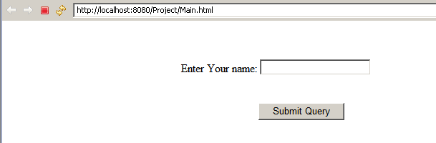

B. We make changes to the program in example 3 to have:

import java.io.IOException;
import javax.servlet.ServletException;
import javax.servlet.annotation.WebServlet;
import javax.servlet.http.HttpServletRequest;
import javax.servlet.http.HttpServletResponse;
import java.sql.*;
import java.util.Scanner;

@WebServlet("/Main")
public class Main extends javax.servlet.
http.HttpServlet implements javax.servlet.Servlet {
static final long serialVersionUID = 1L;

public Main () {
super();
}

protected void doGet(HttpServletRequest request,
HttpServletResponse response)throws ServletException, IOException {

String name = request.getParameter("Aname");
try {
Class.forName("com.mysql.jdbc.Driver").newInstance();
Connection con = DriverManager.getConnection(
"jdbc:mysql://localhost/?user=root&password=");
Statement stmt = con.createStatement();
stmt.execute("USE mydatabase");
stmt.execute("CREATE DATABASE IF NOT EXISTS mydatabase");
stmt.execute("DROP TABLE IF EXISTS simple");
stmt.execute("CREATE TABLE IF NOT EXISTS simple( name char(30))");
//Note that the variable is not part of the string.
String s = "Insert into simple values(\"" + name + "\")";
if(name != null)
stmt.execute(s);
ResultSet rs = stmt.executeQuery("Select * from simple");
while ( rs.next())
System.out.println(rs.getString(1));
} catch (Exception ex) {
System.out.println(ex);
System.exit(0);
}
System.out.println("Program terminated with no error.");
}
}

Description

In this program, we removed:

import java.util.Scanner;
Scanner key = new Scanner(System.in);
System.out.print("Enter a name: ")
String name = key.nextLine();

And added the following instruction:

String name = request.getParameter("name");

Therefore the servlet gets the name from the input box of the html document.
Exercise: Create a Web application that allows the user to enter a person's name (first and last), and then stores that name in a database. The Web application must provide a listing of all of the names, in alphabetical order, by last name. This listing of names must be provided in an HTML table.

